

Individual Assessment Coversheet
To be attached to the front of the assessment.
Campus: Tyger Valley __________________________________________________________________________
Faculty: IT __________________________________________________________________________
Module Code: ITEPA3-33 __________________________________________________________________________
Group: 2 __________________________________________________________________________
Lecturer’s Name: Dr Sandura Shumba __________________________________________________________________________
Student Full Name: Dian Miles __________________________________________________________________________
Student Number: Eduv4933581 __________________________________________________________________________

Indicate | Yes | No
Plagiarism report attached

Declaration:
I declare that this assessment is my own original work except for source material explicitly acknowledged. I also declare that this assessment or any other of my original work related to it has not been previously, or is not being simultaneously, submitted for this or any other course. I am aware of the AI policy and acknowledge that I have not used any AI technology to generate or manipulate data, other than as permitted by the assessment instructions. I also declare that I am aware of the Institution’s policy and regulations on honesty in academic work as set out in the Conditions of Enrolment, and of the disciplinary guidelines applicable to breaches of such policy and regulations.

Signature | Date 8/14/2026

Lecturer’s Comments:

Marks Awarded: |  | %
Signature | Date

Eduvos (Pty) Ltd. (formerly Pearson Institute of Higher Education) is registered with the Department of Higher Education and Training as a private higher education institution under the Higher Education Act, 101, of 1997. Registration Certificate number: 2001/HE07/008

Dian Miles
Eduv4933581
ITEPA3-33 Formative Assignment
Tyger Valley Campus

Deliverable 1:
Domain Model Output:
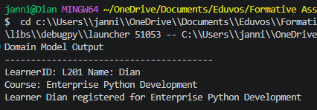
Factory Pattern Demonstration:
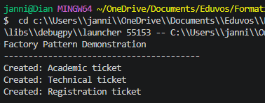
Strategy Pattern Demonstration:
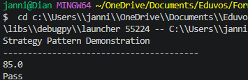
Singleton Pattern Demonstration: (note, when I instantiate the AppConfig instance I give the max_course_capacity a default value of 50, then I try to override that value with my second instance with a value of 100, but it remains 50. Ultimately demonstrating a successful implementation of the singleton pattern)
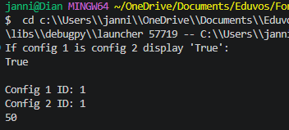

Deliverable 2
2.1 & 2.3)
Registration Process Engine without concurrency:
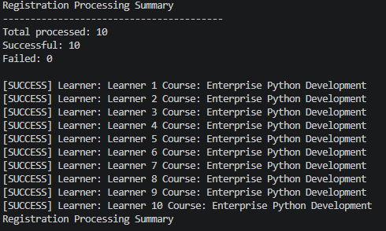
Registration Process Engine with concurrency:
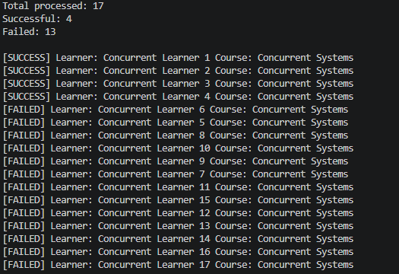

2.2)
Approach A:
(My current solution): The registration data of the application is modelled using a Python list, which is distributed across all the objects that own them instead of it being centralised in one place. For example, my learner class holds its own list of Registration objects, my Course class holds its own list of Registration objects, and my Registration engine in deliverable 2 holds a single list of RegistrationResult objects. Since each of these lists will only grow with a natuarally small, bounded amount, append operations will stay O(1), meaning it wont degrade the system.
Approach B:
My second option would be to use a dictionary for registries, for example I would have a global dictionary variable that maps to a list of registrations, or a set of learner_ID and course_ID pairs. The benefit that I would have gained from this approach would be faster look up times, with a time complexity of O(1); specifically, for checking whether a learner is already registered for a course in comparison to scanning a list. However, this approach would introduce additional complexities such as keeping a separate structure in sync with the Learner and Course objects.
Conclusion:
After weighing both options, I chose Approach A, as the performance gains Approach B offers are minimal at the scale of the scenario, while also introducing added complexity through keeping a separate structure in sync. Approach A already meets the scalability, maintainability, and performance requirements without that overhead, ultimately making it the better fit for this application

Deliverable 3
3.1)
For my Bugzot Monitoring system, I decided to use the singleton pattern for its implementation as well to only allow creating a single instance of the monitoring system.
I also used a Lock to prevent race conditions, as multiple threads can try to access and update the “error_count” variable

# Bugzot Monitoring system

import logging
import threading # for the lock

# use singleton pattern for monitoring system
class Bugzot():
__instance = None

# Creation, not instantiating
def __new__(cls,*args,**kwargs):
if cls.__instance is None:
cls.__instance = super().__new__(cls)
cls.__instance.__initialized = False
return cls.__instance

# Instantiation
def __init__(self,log_file ="bugzot_log.txt"):
# return if already initialized
if self.__initialized:
return

# set the "flag" that was added to __instance to true, indicating an instance exists
self.__initialized = True

# Logging configuration
logging.basicConfig(
filename=log_file,
level=logging.DEBUG,
format='%(asctime)s | %(levelname)s | %(message)s',
datefmt='%Y-%m-%d %H:%M:%S'
)

# keep track of the total amount of errors
self.error_count = 0

# Since multiple threads can log errors at once, I will protect it with a lock
self.__lock = threading.Lock()

def log(self,level,category,message):
full_message = f"{category} | {message}"
level = level.upper() # just make it all caps

if level == "ERROR":
with self.__lock:
logging.error(full_message)
self.error_count += 1
elif level == "WARNING":
logging.warning(full_message)
else:
logging.info(full_message)

Within my deliverable 2 where I created the Registration engine, I then imported the Buzgot class and its “log” method to write logs of what is monitored to a file named “bugzot_log.txt”. The output is as follows:
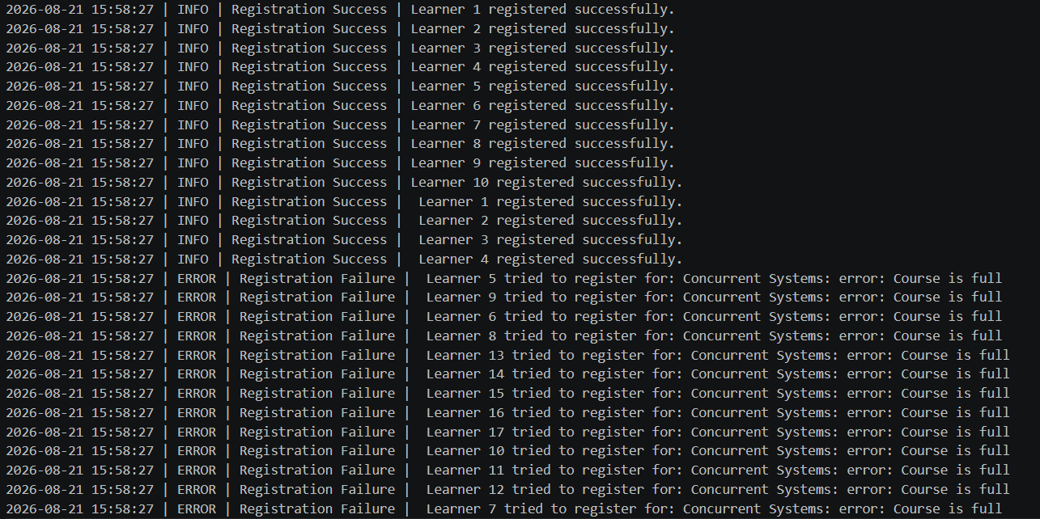
3.2)
For this question, I will extend my current bugzot monitoring solution to monitor and log the performance statics of the system such as how many transactions ran in total.
I will create a wrapper called “track” which I will decorate my “process_registration” method in my RegistrationEngine class. It will use libraries such as “time.perf_counter” ( a high resolution monotonic timer used to benchmark and measure code execution time)
Code for function in deliverable 3:
def track(self,func):
def wrapper(*args,**kwargs): # args - takes input and puts into a tuple | kwargs - takes input (ex num =1) and puts it into a dict
start = time.perf_counter() # what happens before function wrapped by decorator runs
result = func(*args,**kwargs)
elapsed = time.perf_counter()-start #what happens after function wrapped by decorator runs

# use lock again to prevent multiple threads from accessing and modifying
# the vars that help me track the performance of the transactions
with self.__lock:
self.transaction_count += 1
self.total_time += elapsed

# Now i will use the logging configuration which is already inside the
# deliverable 2 function to log this
self.log("INFO","Performance",f"{func.__name__} completed in {elapsed*1000:.2f}ms") # convert to milliseconds for better readability

return result

return wrappe
Code showing the function created being implemented as a decorator on the RegistrationEngine class’s process_registration method
@Bugzot().track # performance wrapper created in deliverable 3
def process_registration(self,learner,course):

Screenshots displaying the output (output written to the log file), take note of the execution time at the end of the successful transactions:
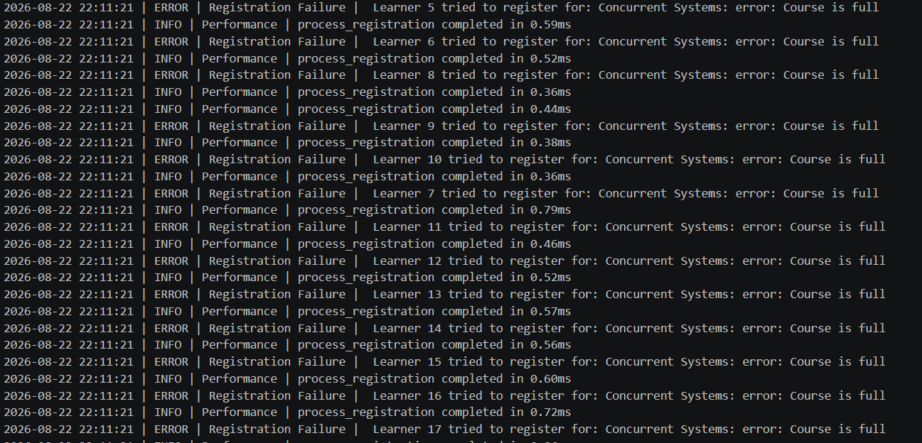

Screenshot showing an additional log/category called “performance”.
Function to generate report:
def generate_report(self):
total_errors = self.error_count
total_time = self.total_time
transaction_count = self.transaction_count

print("------ Performance Report -----")
print(f"Total amount of errors: {total_errors}\nTotal amount of time: {total_time}\nTotal amount of transactions: {transaction_count}")

with self.__lock:
self.error_count = 0
self.total_time = 0
self.transaction_count = 0

return

Terminal Output:
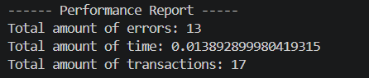

3.3)
Bottleneck Identified:
After analysing my application, I identified one crucial factor that is bottlenecking the performance, and it is associated with how my logs are being written to my bugzot_logs.txt file.
My current implementation of the bugzot monitoring system writes each log individually to the text file. Bugzot.log() calls Pythons logging module, which is configured to write to the text file on disk. Although my thread pool solution registrations in parallel, each one still pays the disk-write cost and threads can even contend over the same log file logging lock, rather than parallelising that part of the work
Proposed solution:
Create a buffer when initialiaing the Bugzot Monitoring class.
Thus, instead of having a disk write per log call, I will have one batch write for all entries.

Comparing the execution time of my first implementation against my the implemented solution that I proposed:
First implementation output to log file:
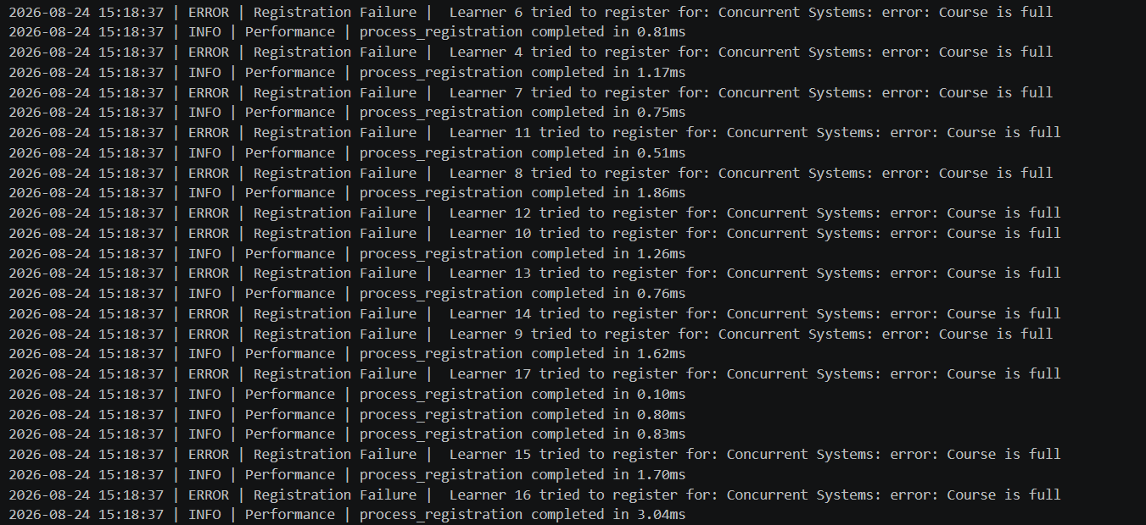
Output for the suggested solution to the bottleneck:
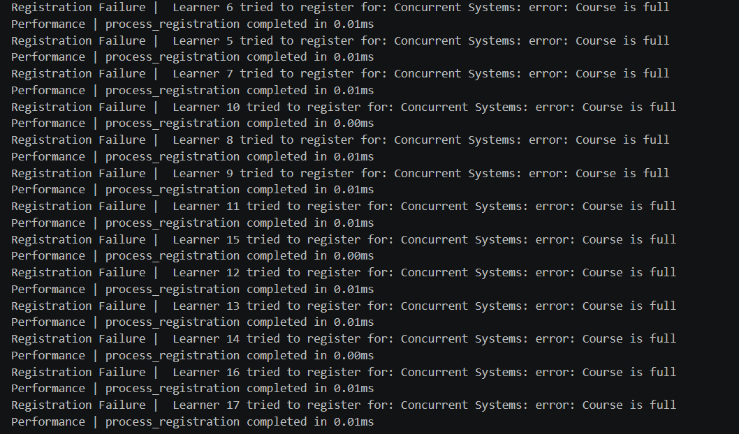
Taking a closer look at the completion time for each registration, the average time of execution before the buffer is 1.17ms.
After implementing the buffer the average time to execution is 0.0076ms.
Thus, the average measured time improved by 99.35%.
Code for the performance enhancement implementation:
Firstly, I created a buffer variable in my current Bugzot class:
self.__buffer = [] # add buffer to avoid the bottleneck

Secondly, Instead of sequentially writing to the “bugzot_log.txt file”, I changed my log() function to append to the buffer.
# for question 3.1 -- Just monitor registration attempts, errors and warnings such as duplicate registrations
def log(self,level,category,message):
full_message = f"{category} | {message}"
level = level.upper() # just make it all caps

# refine function to append to the buffer rather than directly writing to the log
with self.__lock:
self.__buffer.append(full_message)
if level == "ERROR":
self.error_count += 1

Lastly, I created a “flush()” function to write all contents to the file then clear the buffer for the next round of transactions
def flush(self):
with open(self.log_file, "a") as f:
f.write("\n".join(self.__buffer)+"\n")
self.__buffer.clear()

I then simply added the “flush()”method to the “generate_report()” method.
def generate_report(self):
total_errors = self.error_count
total_time = self.total_time
transaction_count = self.transaction_count

print("------ Performance Report -----")
print(f"Total amount of errors: {total_errors}\nTotal amount of time: {total_time}\nTotal amount of transactions: {transaction_count}")

#single batch will write to the disk here using my flush function
self.flush()

# now reset these values with the Lock
with self.__lock:
self.error_count = 0
self.total_time = 0
self.transaction_count = 0

return

Deliverable 4
4.1)
User registering for a course:
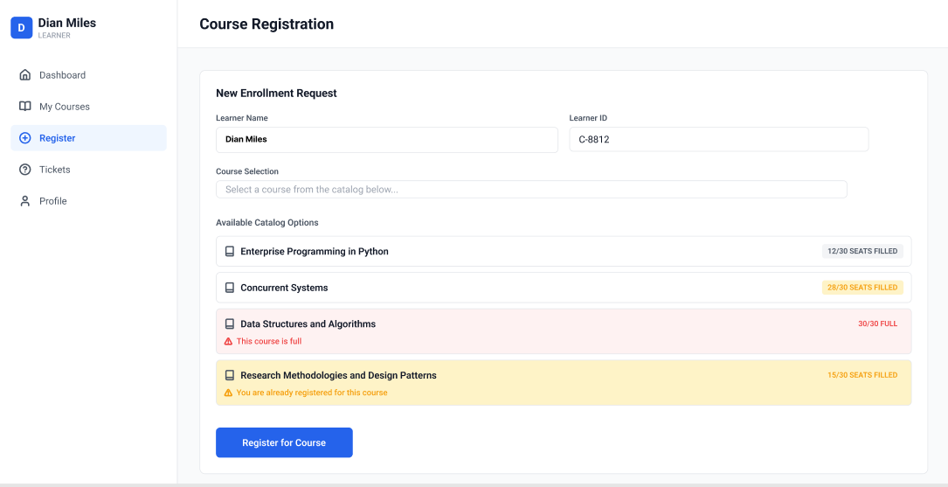

Admins managing courses:
They can either select the “add course” button or simply fill in the fields below the existing courses
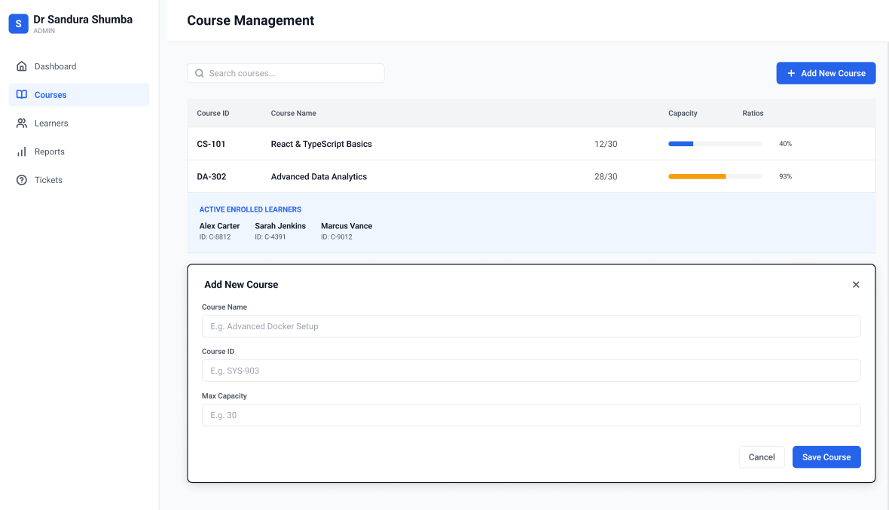

Learners Creating Support Tickets:
Learners can select a ticket type (as listed in deliverable 1 for the factory pattern) and submit the ticket. Upon submission, they will be presented with a toast to indicate they have successfully submitted the ticket
They can also see their previously submitted tickets, as well as the status of those tickets.
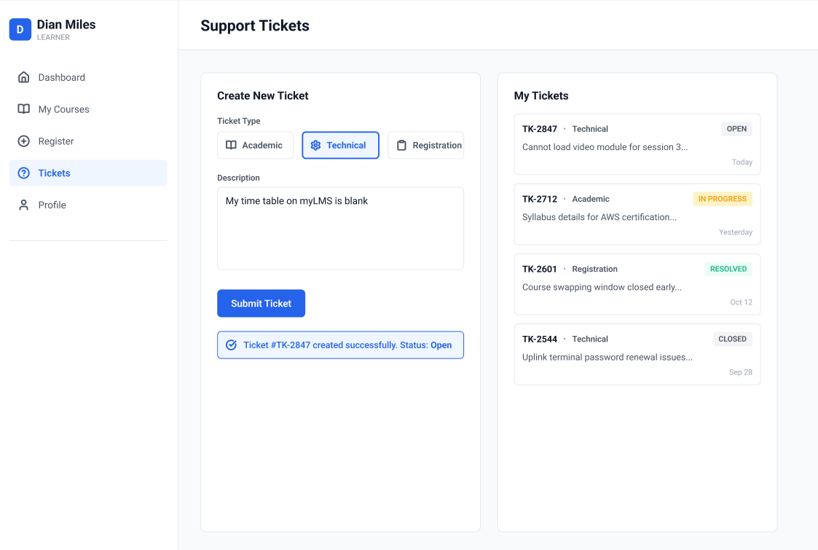

Admins viewing reports:
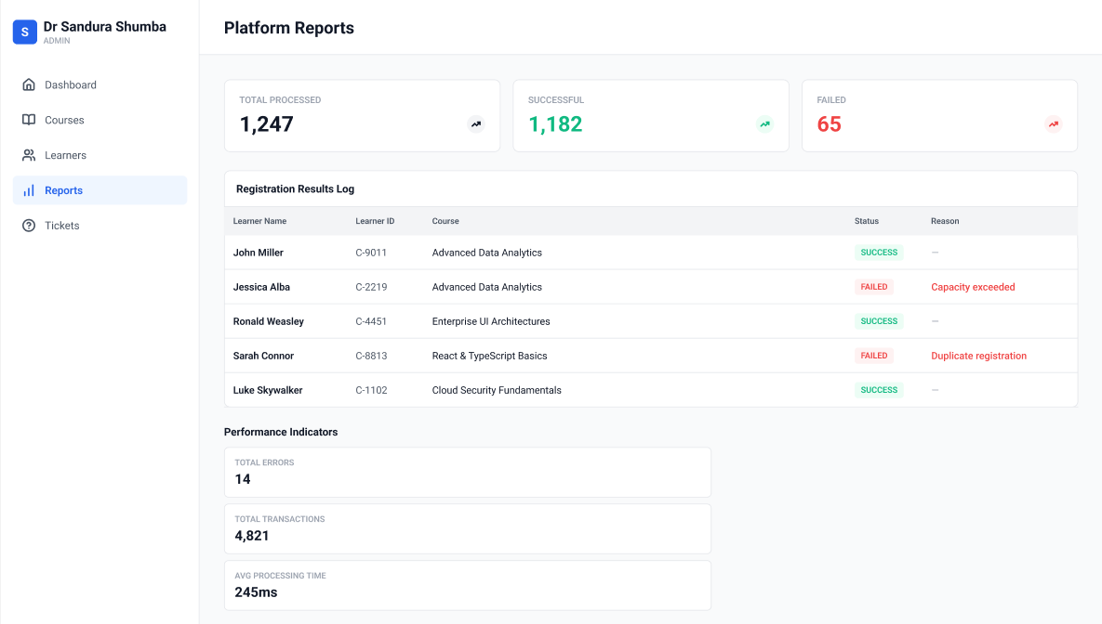
My design decisions made for the mock-up:
- Layout – I chose a siderbar with a main content panel structure for the user interface because it scales well as more screens get added on later on. This layout accommodates for screens to be added (for example an settings tab) without having to redesign the layout
- Navigation – for the navigation I made my siderbar “role-based”, with each role being indicated by an icon and name related to the role. This approach reduces clutter, and makes it easy for both admins and learners to navigate the system. It also makes it easy to manage admin views and learner views as I will simply hide and restrict the roles in the sidebar that learners shouldn’t be able to view.
- Usability – All of the components in my mockup that have a form of status associated with them, are indicated through iconography and colour rather than simply displaying text. Red is associated with errors or failures, yellow is associated with pending statuses such as pending tickets, and green is associated with success messages. When users complete interactions, they will also be presented with toasts/ pop ups to give the user feedback that the transaction/process they were trying to commit has been executed.
- Validation – validations are done before submissions are made where applicable, for instance when a learner is on the registration screen it will show “course is full” or “you are already registered for this course”. I chose this approach as it reflects the duplicate registration and capacity limit rules that I enforced in my “RegistrationEngine” class in deliverable 2.
Strengths of my design:
The current design of my mock-up UI cleanly maps to my existing backend logic , for instance every validation rule that’s already implemented in my RegistrationEngine has corresponding, visible UI state, thus the interface actually reflects system behaviour.
My reporting screen also displays the performance-monitoring logic from my Bugzot monitoring class, which gives admins an insight into the system health and state, not just the transaction outcomes.
My UI also presents a clean, easy to navigate design which makes it easy for users to navigate their way through the system.
Limitations of my design:
Though my registration screen shows capacity and duplicate-registration warnings, my current design has no real-time feedback for concurrent registration attempts, meaning that if two learners are contending for the last spot available in a course at the same time, my UI gives no indication that the seat count might already be stale by the time one of the learners click “Register”
Solution I recommend:
I will add a brief “loading” or “confirming” state when the “Register for course” button is pressed paired with some form of live-updating (meaning no manual refresh) seat count, to keep the displayed number of seats actually available and give the user a clear indication of what’s happening after clicking “Register” as they will see that the system is checking whether the displayed number or learners registered reflects the actual amount of students that have registered.

Deliverable 5

5.1)
For my test case, I will be using Pytest
First Attempt of running tests
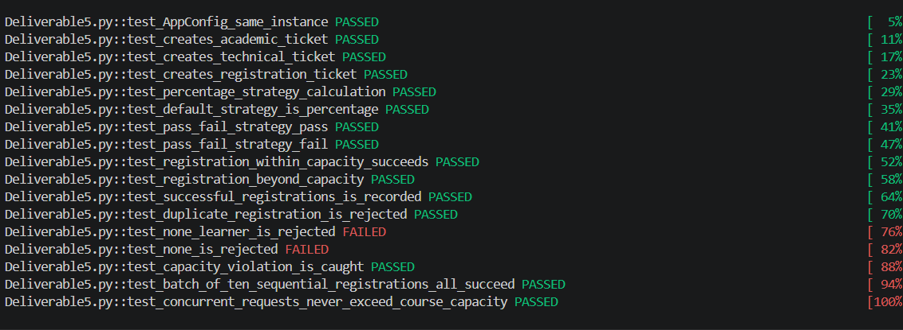
Test case results after fixes:
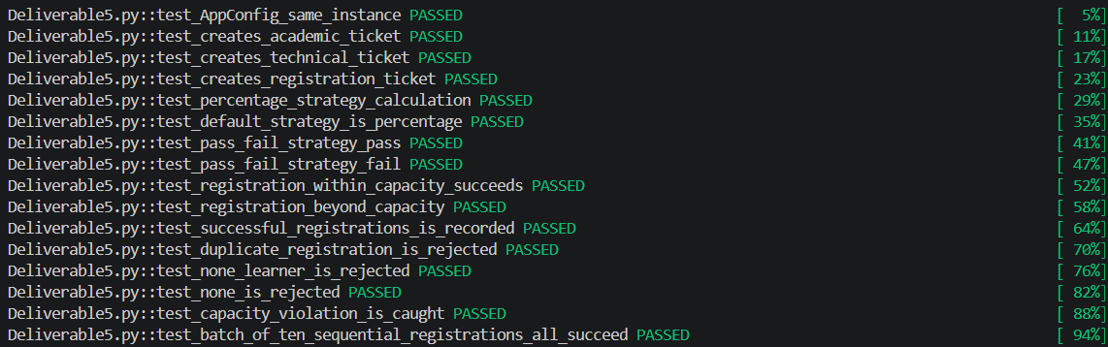
All Test Cases:
from Deliverable1 import *
from Deliverable3_extended import RegistrationEngine
from Deliverable3_extended import Bugzot

def reset_bugzot():

'I will have to rest the bugzot instance because its a singleton pattern'
'I will call this method at the start of every test function'
Bugzot._Bugzot__instance = None

# Testing the singleton pattern for my App Config
def test_AppConfig_same_instance():
config1 = AppConfig()
config2 = AppConfig(max_course_capacity=999)
assert config1 is config2

# Test my SupportTicketFactory
def test_creates_academic_ticket():
learner = Learner("Eduv1","Test Learner")
ticket = SupportTicketFactory.create_ticket("academic",learner,"Missed Exam")
assert isinstance(ticket,AcademicTicket)

def test_creates_technical_ticket():
learner = Learner("Eduv2","Test Learner")
ticket = SupportTicketFactory.create_ticket("technical",learner,"myLMS is down")
assert isinstance(ticket,TechnicalTicket)

def test_creates_registration_ticket():
learner = Learner("Eduv3","Test Learner")
ticket = SupportTicketFactory.create_ticket("registration",learner,"Incorrect Course")
assert isinstance(ticket,RegistrationTicket)

# Test strategy pattern - Assessment result calculation
'Check that correct percentage is calculated'
def test_percentage_strategy_calculation():
assessment = Assessment("ITDSA","Data Structures in Python",100,PercentageStrategy())
assessment.set_score(85)
assert assessment.get_result() == 85.0

'Check that the default strategy is percentage calculation'
def test_default_strategy_is_percentage():
assessment = Assessment("ITSEA","Software Architecture",50)
assessment.set_score(25)
assert assessment.get_result() == 50

'Check that if a learner '
def test_pass_fail_strategy_pass():
assessment = Assessment("ITDMA", "Pass Fail Quiz", 100, PassFailStrategy())
assessment.set_score(60)
assert assessment.get_result() == "Pass"

def test_pass_fail_strategy_fail():
assessment = Assessment("ITDMA", "Pass Fail Quiz", 100, PassFailStrategy())
assessment.set_score(30)
assert assessment.get_result() == "Fail"

def swop_strategy_at_runtime():
assessment = Assessment("ITOPA", "Swap",100,PercentageStrategy())
assessment.set_score(70)
assert assessment.get_result() == 70.0
# swop the method
assessment.set_strategy(PassFailStrategy())
assert assessment.get_result() == "Pass"

# Test business rules

def test_registration_within_capacity_succeeds():
course = Course("ITJA","Testing in Java",max_capacity=2)
learner1 = Learner("Eduv1", "Alice")
learner2 = Learner("Eduv2", "Bob")

Registration(learner1,course)
Registration(learner2,course)

assert len(course._Course__registrations) == 2

def test_registration_beyond_capacity():
course = Course("ITDMA","Research course FULL CAPACITY",max_capacity=1)
learner1 = Learner("Eduv45","Chris")
learner2 = Learner("Eduv46","Monje")

Registration(learner1,course)
raised = False
try:
Registration(learner2,course)
except ValueError:
raised = True
assert raised

# RegistrationEngine test - validations, duplicates, summaries

def test_successful_registrations_is_recorded():
reset_bugzot()
engine = RegistrationEngine()
course = Course("ITSSA","Networking and Security",max_capacity=5)
learner = Learner("L10","Eve")

engine.process_registration(learner,course)

results = engine._RegistrationEngine__results
assert len(results) == 1
assert results[0].success

def test_duplicate_registration_is_rejected():
reset_bugzot()
engine = RegistrationEngine()
course = Course("ITSEA","Software Architecture",max_capacity=5)
learner = Learner("L11","Frank")

engine.process_registration(learner,course) # my first registration should succeed
engine.process_registration(learner,course) # my second registration should fail due to duplicate registration

results = engine._RegistrationEngine__results
assert len(results) == 2
assert results[0].success # success for first
assert not results[1].success # should fail
assert "Duplicate" in results[1].reason # reason should be duplicate registration

def test_none_learner_is_rejected():
reset_bugzot()
engine = RegistrationEngine()
course = Course("ITEPA", "Enterprise Python", max_capacity=5)

engine.process_registration(None,course)
results = engine._RegistrationEngine__results
assert len(results) == 1
assert not results[0].success
assert "Invalid" in results[0].reason

def test_none_is_rejected():
reset_bugzot()
engine = RegistrationEngine()
learner = Learner("Eduv67","Thato")

engine.process_registration(learner,None)

results = engine._RegistrationEngine__results
assert not results[0].success
assert "Invalid" in results[0].reason

def test_capacity_violation_is_caught():
reset_bugzot()
engine = RegistrationEngine()
course = Course("ITPPA","Programming in Python",max_capacity=1)
learner1 = Learner("Eduv1","James")
learner2 = Learner("Eduv5","Rassie")

engine.process_registration(learner1, course) # fills capacity
engine.process_registration(learner2, course) # should fail and catch violation

results = engine._RegistrationEngine__results
assert results[0].success
assert not results[1].success

#the engine should no not crash and properly handle the error
assert "Error" in results[1].reason

def test_batch_of_ten_sequential_registrations_all_succeed():
reset_bugzot()
engine = RegistrationEngine()
course = Course("ITAPA","Concurrent Systems",max_capacity=10)
# create a few learners
learners = [Learner(f"Eduv{i}",f"Learner {i}") for i in range(10)]

for learner in learners:
engine.process_registration(learner,course)

results = engine._RegistrationEngine__results
assert len(results) == 10
assert all(r.success for r in results)

# Arguably the most important part of my system
# - Test the concurrency safety of concurrent processes

def test_concurrent_requests_never_exceed_course_capacity():
reset_bugzot()
capacity = 4
num_requests = 30
course = Course("ITEPA","Enterprise Programming in Python",max_capacity=capacity)

learners = [Learner(f"Eduv{i}",f"Concurrent learner {i}") for i in range(num_requests)]

engine = RegistrationEngine()
requests = [(learner,course) for learner in learners] # create tuple of learners that want to enroll for the course
engine.process_batch_concurrent(requests,max_workers=10)

results = engine._RegistrationEngine__results
successful = [r for r in results if r.success]
failed = [r for r in results if not r.success]

assert len(results) == num_requests # check that 30 learners tried to register
assert len(successful) == capacity # only 4 learners should have registered successfully
assert len(failed) == num_requests - capacity # total amount of failed learner should be max capacity - total successful registrations

# check that the course's own internal list actually matches the capacity
assert len(course._Course__registrations) == capacity

5.2)
I will be using python’s built in cProfile library at for function-level profiling, and the line-profiler library for line-level profiling, analyse my programs execution time and to identify performance bottlenecks
Running my Profiling.py file:
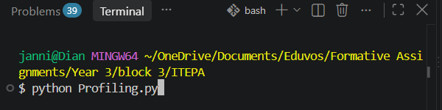
Output results for functional level results:
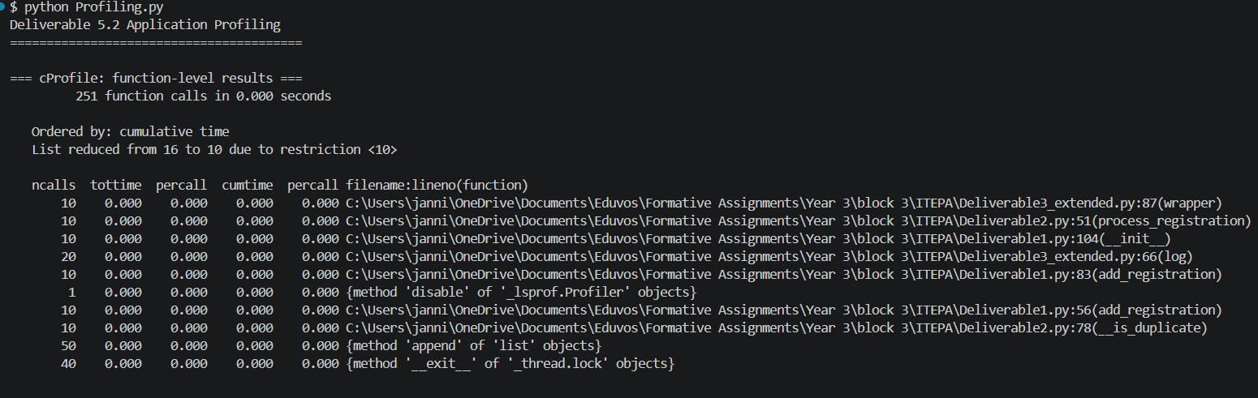
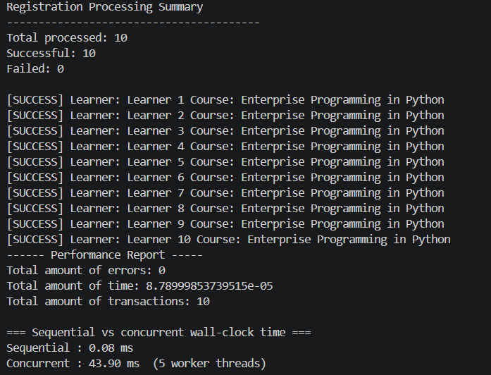

Terminal Output for line-level profiling:
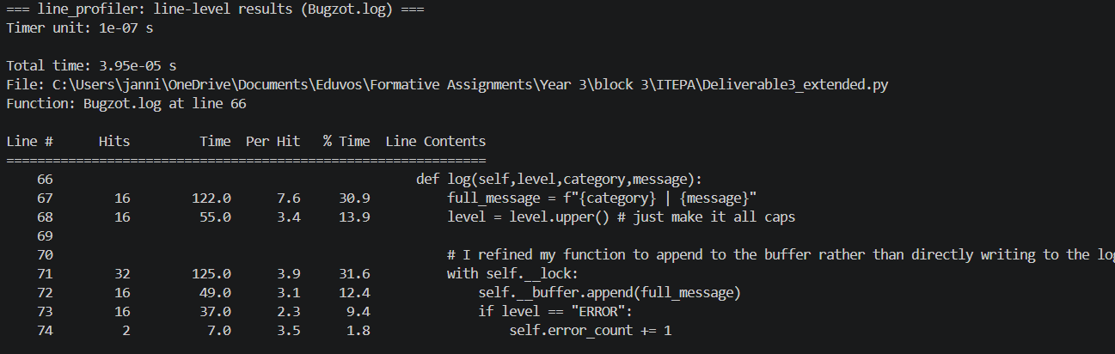
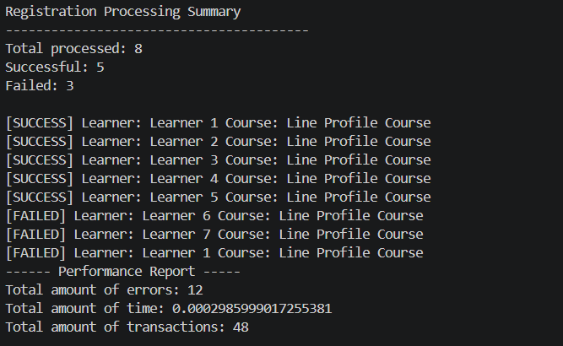

Analysis of the profiling results:
After Analysing my results, I found that running registration concurrently was surprisingly slower than doing them one at a time (7.06ms vs 0.11ms), despite the concurrent approach being the theoretical “faster” option. It turns out that most of that time is just the thread pool doing its setup, and not my actual registration code, which would be a fixed cost that would matter far less once spread across a much larger number of real registration requests instead of my simulated ones.
I also found that inside my “Bugzot.log” function, two lines were eating most of the time.
Acquiring the lock, 31.6%, and then building the log message string, 30.9%.
I believe my current implementation is still well suited for large-scale systems, since the overhead caused by the thread pool would become proportionally smaller as request volume grows. If I wanted to make improvements based on the current scale of my program I would refine those two functions.

All the code for my profiling logic:
import cProfile
import pstats # convert my raw output to sorted tables
import io # capture the output as a text
import time

from line_profiler import LineProfiler

from Deliverable1 import Learner, Course
from Deliverable2 import RegistrationEngine
from Deliverable3_extended import Bugzot

# list to store my logs
REPORT = []

# logging helper to append text to my REPORT list
def log(text=""):
print(text)
REPORT.append(text)

# Function level breakdown
def run_cprofile():
engine = RegistrationEngine()
course = Course("ITEPA", "Enterprise Programming in Python", max_capacity=50)
learners = [Learner(f"Eduv{i}", f"Learner {i}") for i in range(1, 11)]

# create Profile object
profiler = cProfile.Profile()

# start recording
profiler.enable()

for learner in learners:
engine.process_registration(learner, course)

#stop recording
profiler.disable()

# Build the report with the raw profiler data by writing into the in memory buf
buf = io.StringIO()
stats = pstats.Stats(profiler, stream=buf)

# Sort the results by total time spent in a function
stats.sort_stats("cumulative")
stats.print_stats(10)

log("\n=== cProfile: function-level results ===")
log(buf.getvalue())
engine.print_summary()

# Sequential vs concurrent time - context for the cProfile numbers
def compare_sequential_vs_concurrent():
import concurrent.futures

# sequential timing
engine1 = RegistrationEngine()
course1 = Course("ITOPA", "Cloud Computing", max_capacity=10)
learners1 = [Learner(f"Eduv{i}", f"Learner {i}") for i in range(20)]

start = time.perf_counter() # grab current time
for learner in learners1:
engine1.process_registration(learner, course1)
sequential_time = time.perf_counter() - start #grab time again and subtract elapsed seconds

# concurrent timing with the same volume, run through a thread pool
engine2 = RegistrationEngine()
course2 = Course("ITCOA", "Concurrent Systems", max_capacity=20)
learners2 = [Learner(f"Eduv{i}", f"Learner {i}") for i in range(20)]
requests = [(learner, course2) for learner in learners2]

start = time.perf_counter() # grab current time
engine2.process_batch_concurrent(requests, max_workers=5)
concurrent_time = time.perf_counter() - start #grab time again and subtract elapsed seconds

log("\n=== Sequential vs concurrent wall-clock time ===")
log(f"Sequential : {sequential_time*1000:.2f} ms") # convert to milliseconds with :.2f format
log(f"Concurrent : {concurrent_time*1000:.2f} ms (5 worker threads)")

# line_profiler: line-level breakdown of Bugzot.log
# specifically watch the function line by line
def run_line_profiler():
lp = LineProfiler()
lp.add_function(Bugzot.log)

engine = RegistrationEngine()
course = Course("ITLPC", "Line Profile Course", max_capacity=5)
learners = [Learner(f"Eduv{i}", f"Learner {i}") for i in range(1, 8)] # 8 requests, 5 seats

lp.enable_by_count() # start counter
for learner in learners:
engine.process_registration(learner, course) # exercises success + capacity-violation
engine.process_registration(learners[0], course) # exercises duplicate-registration branch
lp.disable_by_count() # end counter

# capture report into a string buffer, log it, and then print the registration summary
buf = io.StringIO()
lp.print_stats(stream=buf)

log("\n=== line_profiler: line-level results (Bugzot.log) ===")
log(buf.getvalue())
engine.print_summary()

if __name__ == "__main__":
log("Deliverable 5.2 Application Profiling")
log("=" * 40)

run_cprofile()
compare_sequential_vs_concurrent()
run_line_profiler()

# write results to a file
with open("profiling_results.txt", "w") as f:
f.write("\n".join(REPORT))

print("\nResults saved to: profiling_results.txt")

5.3)
  - Candidate services for the microservices architecture:
Learner Service:
This service would be responsible for owning a learner’s identity and registration history
Responsibilities:
Create and store learner profiles
Track which courses a learner is registered
Expose learner lookup to other services via API

Course Service:
The course service would own course definitions and the maximum enrolment capacity, so it handles what the courses will be made up of as well as how much room is available for each course
Responsibilities:
- Create and store course details such as the coursed, name, and maximum capacity
- Track the current enrolment count per course
- Enforce and expose the capacity check that Registration depends on

Registration Service:
This service will own and handle the registration process itself, it will essentially be the layer that ties the learner and course service together
Responsibilities:
- Validate incoming registration requests such as checking for duplicity and course capacity
- Process batches of registrations, including concurrent request handling during peak hours
- Publish the outcome of registration events for the Monitoring service to consume

Assessment Service:
The assessment service will oversee scoring and result calculations.
Responsibilities:
- Record and validate scores against a maximum of a specific assessment
- Calculate results using a pluggable strategy (My strategy pattern) for either percentage or assessing whether a learner passed or failed
- Allow the calculation strategy to be swopped without touching stored scores
Support Ticket Service:
This service will win the creation of support tickets
Responsibilities:
- Create tickets of different types such as academic, technical or registration via the ticket factory
- Link tickets back to the learner who raised them
- Track the status of tickets

Monitoring Service:
This service will own the observability for the entire system. This will be the one service that every other service communicates with, but also doesn’t communicate back to them
Responsibilities:
- Consume events published by other services such as errors, warnings, or performance data
- Keep track of the total amount of errors that occur as well as transaction and performance metrics
- Generate reports based on the information that was communicated by other services

Service Communication
The services can communicate with each other through two different mechanisms, depending on the needs of a service
Synchronous Communication:
Typically making use of REST API’s, this method is for anything that needs an immediate response before it can proceed. For example, Registration calling Course to check the capacity, or Registration calling learner to check for a duplicate.
Asynchronous Communication:
This form of communication is typically done through message brokers and will most likely be used by services such as the Monitoring Service. In this case, each microservice just publishes an event such as “registration succeeded” or “capacity violation” to the broker and then moves on. The Monitoring Service can then consume those published events independently, decoupled from whether its fast, slow, or even down for a brief period.

Testing and Tracing Requirements
One key factor that should always be taken into consideration when adopting or migrating to a microservices architecture is the complexity that comes along with it. Thus, testing and tracing the requirements are non-negotiables
Testing:
Test cases should be written for each microservice before deployment as the overall structure and communication methods will look significantly different to that of a monolithic architecture.
The most important form of tests are the contract/integration tests between services. An example of this would be verifying the Registration service’s REST call to the Course service matches what Course exposes seeing as these are now separately deployable things that can drift out of sync.
Testing each microservice will ensure that they behave as expected when the time comes to deploy them.

Tracing Requirements:
Given the nature of the microservice architecture, distributed tracing is essential to ensure that communication and operations run smoothly through all microservices.
For example, a single registration requests now effects the Registration, Course, Learner, and asynchronously the Monitoring service. Thus, it is essential to have some form of tracing ID that is attached to the request and propagated through every hop to make it easier to troubleshoot if an error occurs. Tools such as OpenTelemetry exists for this exact purpose.

Independently Executable Services
The list of services that can execute independently, meaning none of them calls out to another service to do its own job are the Support Ticket and Monitoring service. These two services classify as “domain independent” as they contain generic capabilities that could be reused outside this system entirely.
Though the Learner, Course and Assessment services ae technically decoupled, they remain conceptually tied to the registration Service

Diagram Illustration of Service Communication

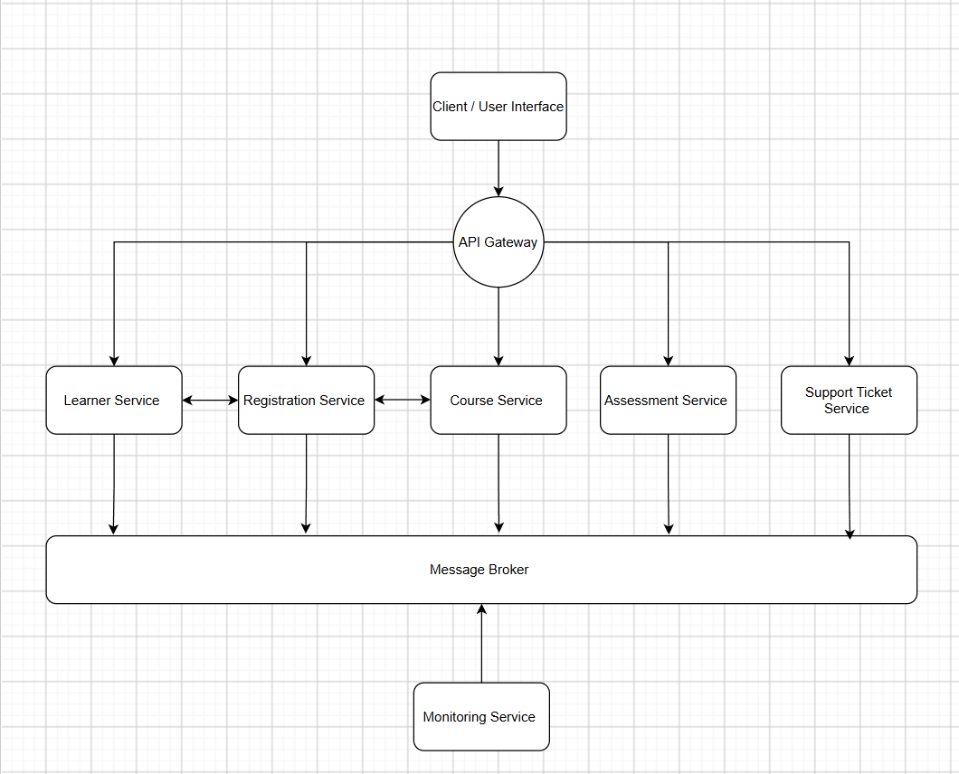

Bibliography

- Python Software Foundation (no date) Concurrent.futures - launching parallel tasks, Python documentation. Available at: https://docs.python.org/3/library/concurrent.futures.html (Accessed: 22 August 2026).

- Python Software Foundation (no date b) Time - Time Access and conversions, Python documentation. Available at: https://docs.python.org/3/library/time.html (Accessed: 22 August 2026).

- Tyszberowicz, S., Heinrich, R., Liu, B., Liu, Z. (2018). Identifying Microservices Using Functional Decomposition. In: Feng, X., Müller-Olm, M., Yang, Z. (eds) Dependable Software Engineering. Theories, Tools, and Applications. SETTA 2018. Lecture Notes in Computer Science(), vol 10998. Springer, Cham. https://doi.org/10.1007/978-3-319-99933-3_4

- Aksakallı, I. K., Çelik, T., Can, A. B., & Tekinerdogan, B. (2021). Deployment and communication patterns in microservice architectures: A systematic literature review. Journal of Systems and Software, 180, 111014. https://doi.org/10.1016/j.jss.2021.111014

- Parker, A., Spoonhower, D., Mace, J., Sigelman, B. and Isaacs, R., 2020. Distributed tracing in practice: Instrumenting, analyzing, and debugging microservices. O'Reilly Media.

